Steven R. Wilson
2236 Bent Tree Lane Mendota Heights, MN 55120
651.994.0994 • Mobile 612.998.1839
steve@tctechwriter.com

PROFESSIONAL PROFILE

Areas of Specialization: Industry Experience:

- Technical Writing and Editing - Manufacturing
- Internet SEO, web development - Software (ERP, MRP)
- Project Management - Technical Sales
- Manufacturing procedural manuals - Consultative Sales
- Software Usage Manuals - Marketing-Copywriting

Work History:

Volt Technical Resources Fall 2007

Responsibilities:
Technical Writing
- Hired by 3M Automotive, to create for its confidential outsource manufacturer, a complete operations manual. (Workflow SOP). Included procurement of raw materials, conversion, manufacturing, packaging, and distribution. Also wrote ERP instruction manual.

Technical Writing Deliverables:
- Workflow SOP (Word; photography) Target: Automotive OEM(s)
Secondary Targets: 3M Quality Engineering, Process Engineering, Manufacturing Operations; Confidential Manufacturer’s Operations Management
Purpose: ISO Compliance for Foreign and Domestic Automotive OEM(s)

- ERP instruction manual (Word) Target: manufacturing department/operations
Secondary Target: 3M Supply Chain Management

Webcetera LLC 2003-2005
Freelance Consultant: Web design and SEO
- Consult on Search Engine Optimization for Internet Marketing firm.
- Created several informational websites for online publishing using Dreamweaver
- Wrote articles on a variety of subjects from recreation to health care
- Edited and maintained article content
- Edited photography using Fireworks
- Edited layout and referencing links by hand-coding HTML

SGS Inc. 2000 – 2007
Responsibilities:
Project Management:
- Create new division for markets new to the company. With a support staff of six, division generated
revenues of nearly $12M in 7 years
- Staffing, training, and detailing new workflows
- Purchasing equipment, designing facilities and physical work areas and traffic patterns for staff

Technical Writing Deliverables:
These are for a pre-press manufacturing company, packaging industry.

- Workflow SOP (Word) (Visio) Target: CSR Department
This document was prepared to delineate where the new division’s manufacturing and
finishing diverged from existing workflows. Order preparation was parallel to existing
workflows, however, with completely different CAD specs. Manufacturing used separate
materials and added new finishing steps for this division.
Steven R. Wilson
2236 Bent Tree Lane Mendota Heights, MN 55120
651.994.0994 • Mobile 612.998.1839
steve@abacusplus.com

PROFESSIONAL PROFILE page 2

SGS Inc. continued…

- QC SOP (Word) Target: Manufacturing Department/Clients
This document provided clients a view of each QC point in our manufacturing workflow.
The objective was to verify QC procedures for clients’ management and their ISO 9000
Regimens.

- Presentation Materials (Word, PDF, Power Point) Target: Marketing/Clients
These documents were created for the company to market itself (nationally) as a primary
source for accounts that needed regional load balancing for manufacturing.

Client Technical Project:
- Analyze client workflow and shorten cycle times for their project quotes. Create and document new workflows and train client Customer Service group leaders on project quoting. Reduced cycle time from 5 days to 2 days.

Technical Writing Deliverables:
This was for a corrugated container manufacturing company, packaging industry.

- Workflow SOP (Visio) Target: Client’s CSR department/management
Two documents were prepared to outline workflow and accountability changes.

CGC
Technical Manager & Customer Service Manager 1985 – 2000

Responsibilities:
Technical writing and training
- Designed training program and educational pieces on flexographic process printing

Technical Writing Deliverables:
- Technical Education Book (Quark, Word) Target: In-house Department Managers
This 15 page book was prepared to train computer graphic operators in flexographic
process printing. Converting and printing industries had begun to evolve in high end
print capabilities.

- Power Point Presentations Target: Clients’ management, operators
One project was a four-hour class for printing press operators using the book described
above, teaching process control, mechanical TIR components.

- Technical Education Book 2 (secondary version) Target: marketing (client base)
This piece was sold to clients to market employer’s technical abilities and proficiency.
Subsequent role: present and train on-site for clients’ staff, with ongoing (monthly) follow-up sessions.

Technical Manager:
- Led the implementation of an ERP system. Early generation (DOS based) system was deployed for production management and scheduling. Worked with vendor to customize for company. Also created the nomenclature for the software to integrate departmental planning.

Technical Writing Deliverables:
- Instruction Manual (Word) Target: CSR and Manufacturing Departments

Steven R. Wilson
2236 Bent Tree Lane Mendota Heights, MN 55120
651.994.0994 • Mobile 612.998.1839
steve@abacusplus.com

PROFESSIONAL PROFILE page 3

CGC Continued…

Customer Service Manager:
- Created and wrote the Standard Operating Procedures

Technical Writing Deliverables:
- SOP Master Book (Quark, Word) Target: CSR Department (ISO 9000 audit)
This was a 62-page book with breakouts for each department. Outlined procedures
and departmental hand-offs for QC inspections and re-work stop points.

- Best Practices books by department (Quark, Word) Target: Department managers/operations
Outlined procedures and departmental hand-offs for QC inspections and re-work stop points.

Customer Service Manager:
- Hired, developed, and delivered training for Customer Service Representatives

Technical Writing Deliverables:
- Order Processing Manual (Quark) Target: CSR Department
This was an 18 page book describing each point of manufacturing and where CSR
personnel touched each work order, and the steps to follow each client order.

Project Management:
- Led a market survey. Commissioned a third party firm to query clients and focus our organization’s efforts on customer expectations, service issues and product development. Role: Lead manager to develop survey focus and formulate formal responses to survey results.

Deliverables:
- Action plan for client base and our firm

Education: Systems/Software Experience:

- BA Political Science - MS Office (Complete)
University of Wisconsin Madison - Fireworks and Dreamweaver
- Carlson School of Management - HTML
University of Minnesota - Acrobat Pro
- Normandale Community College - C-panel
Technical Writing and Marketing Writing - MySQL
- Content Management Programs

Member: Society for Technical Communications www.stc.org
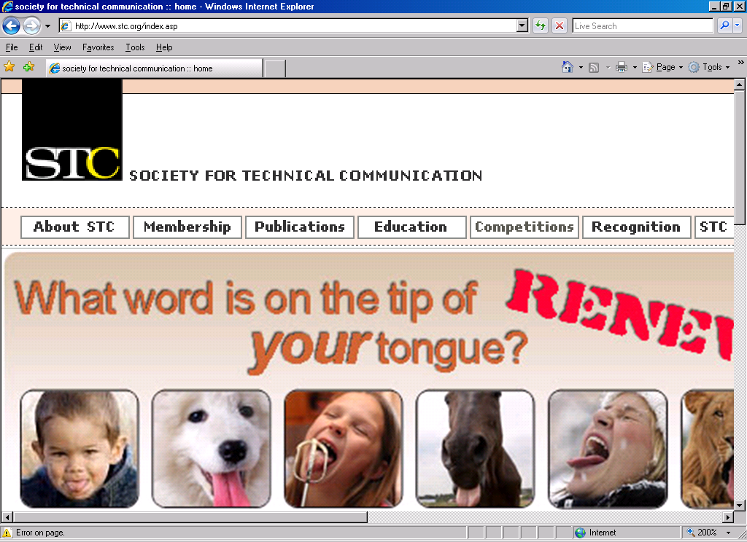

Member: STC Twin Cities www.stctc.org


